Task 1: - Connect your laptop and a friend's phone to the same Wi-Fi network, then use the ping command to check if both devices can communicate with each other. On Windows, use 'ping [IP address]' in Command Prompt; on Android, try a ping app or use Termux.
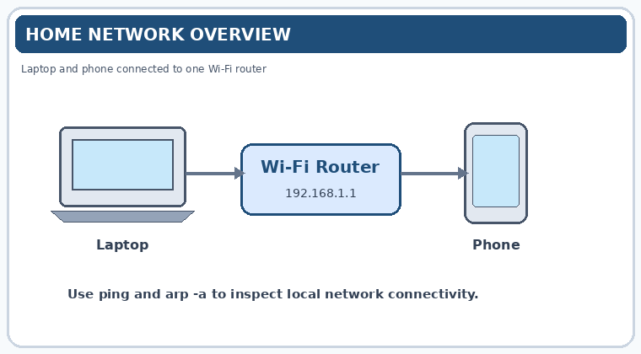

Step 1: Connect both devices
- Connect your Windows laptop to the same Wi-Fi network as your friend's phone.
- Ensure both devices are connected to the same local network.
Step 2: Find the laptop's IP address
- Open Command Prompt on your laptop.
- Run:
ipconfig
3. Note the laptop's IPv4 address under the active Wi-Fi adapter.
Step 3: Find the phone's IP address
On Android, open Settings → Wi-Fi → Connected network details and look for the IP address. The exact menu names vary by phone.
Step 4: Ping the phone from the laptop
In Command Prompt, run the following command, replacing the example address with your friend's phone's actual IP address:
ping 192.168.1.25
You can also test the reverse direction using a ping app or Termux on the phone:
ping <laptop-IP-address>
Press Ctrl + C to stop a continuous ping.
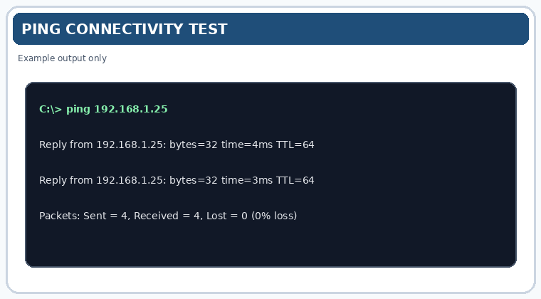
3. Observation Table
Test | Result
Laptop IP address | __________
Phone IP address | __________
Ping from laptop to phone | Successful / Failed
Ping from phone to laptop | Successful / Failed
Packet loss | __________
4. Expected Results
- Successful: Reply messages appear, showing response times in milliseconds.
- Failed: You may see “Request timed out” or “Destination host unreachable.”
A failed ping does not necessarily mean the devices cannot communicate. The phone's firewall, disabled ping responses, or the router's AP/client isolation setting may block ping traffic even when both devices are connected to Wi-Fi.
5. Conclusion
The ping command was used to test connectivity between a laptop and a phone on the same Wi-Fi network. Successful replies indicate that the devices can exchange ICMP echo messages; failed replies require further network troubleshooting.

Task 2: - Run the traceroute (tracert on Windows or traceroute on Mac/Linux) command to www.youtube.com from your device and note down the number of hops it takes to reach the destination.
Practical: Trace the Route to www.youtube.com
1. Objective
To use the tracert command to identify the network hops between your computer and the YouTube website.
2. Procedure (Windows)
- Connect your laptop to the internet.
- Press Win + R, type cmd, and press Enter.
- Run the following command:
tracert www.youtube.com
- Wait for the command to finish. It displays the routers (hops) that packets pass through toward the destination.
- Count the numbered hop lines in the output. If the destination is reached, the final destination line indicates the endpoint.
3. Observation Table
Parameter | Observation
Destination | www.youtube.com
Command used | tracert www.youtube.com
Number of hops | ______
Destination reached? | Yes / No
4. Example Output
Tracing route to www.youtube.com
over a maximum of 30 hops

1 2 ms 1 ms 2 ms 192.168.1.1
2 10 ms 9 ms 11 ms ISP gateway
3 15 ms 14 ms 16 ms Network router
This is illustrative output, not a real trace from your laptop.
5. Result
The tracert command was used to trace the network route to www.youtube.com. The number of hops should be recorded from the actual command output on your device.
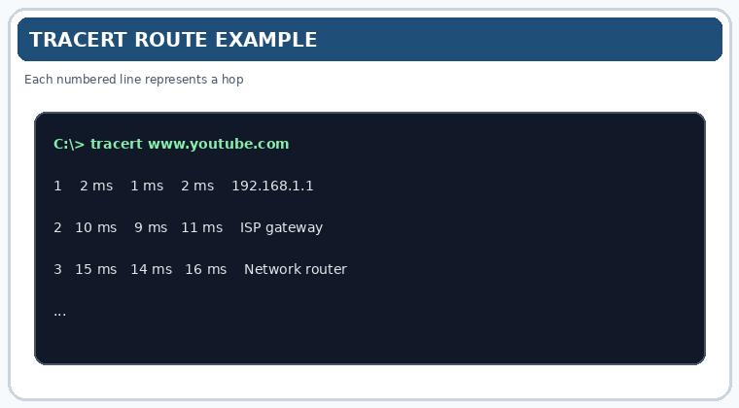

Task 3: - Disconnect one device from the Wi-Fi, then try pinging it again from your laptop and describe the error message you receive.
Practical: Test Ping After Disconnecting a Device from Wi-Fi
1. Objective
To observe the error message displayed when a device is disconnected from Wi-Fi and pinged from a laptop.
2. Procedure
- Connect your laptop and a mobile phone to the same Wi-Fi network.
- Find the phone's IP address in its Wi-Fi network details.
- Open Command Prompt on your laptop and run:
ping 192.168.1.25
Replace the example IP address with the phone's actual IP address.
- Disconnect the phone from Wi-Fi.
- Run the same ping command again and observe the output.
3. Expected Observation
Example Command Prompt output
Pinging 192.168.1.25 with 32 bytes of data: Request timed out. Request timed out. Request timed out. Request timed out. Ping statistics for 192.168.1.25: Packets: Sent = 4, Received = 0, Lost = 4 (100% loss)
4. Result
After the phone was disconnected from Wi-Fi, the laptop was expected to receive “Request timed out” messages because the phone no longer responded to ping requests over the local network.
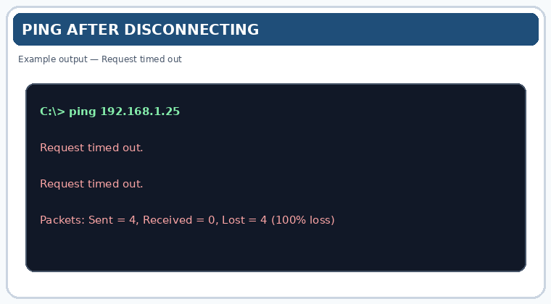
------------------------------------------------------------------------------------------------------------------------
Task 3: - Disconnect one device from the Wi-Fi, then try pinging it again from your laptop and describe the error message you receive.
1. Objective
To observe the error message displayed when a device is disconnected from Wi-Fi and pinged from a laptop.
2. Procedure
- Connect your laptop and a mobile phone to the same Wi-Fi network.
- Find the phone's IP address in its Wi-Fi network details.
- Open Command Prompt on your laptop and run:
ping 192.168.1.25
Replace the example IP address with the phone's actual IP address.
- Disconnect the phone from Wi-Fi.
- Run the same ping command again and observe the output.
3. Expected Observation
Example Command Prompt output
Pinging 192.168.1.25 with 32 bytes of data: Request timed out. Request timed out. Request timed out. Request timed out. Ping statistics for 192.168.1.25: Packets: Sent = 4, Received = 0, Lost = 4 (100% loss)
4. Result
After the phone was disconnected from Wi-Fi, the laptop was expected to receive “Request timed out” messages because the phone no longer responded to ping requests over the local network.

Task 4: - Create a simple table listing the IP addresses of all devices connected to your home Wi-Fi (use 'arp -a' on Windows), and identify which device belongs to which person or gadget.
Practical: List Devices Connected to Home Wi-Fi Using arp -a
1. Procedure
- Connect your Windows laptop to your home Wi-Fi network.
- Open Command Prompt by pressing Win + R, typing cmd, and pressing Enter.
- Run the following command:
arp -a
- The command displays IP addresses, physical (MAC) addresses, and entry types for devices your laptop has recently learned about on the local network.
- Compare the IP addresses with your router's connected-device list to identify which device belongs to each person or gadget.
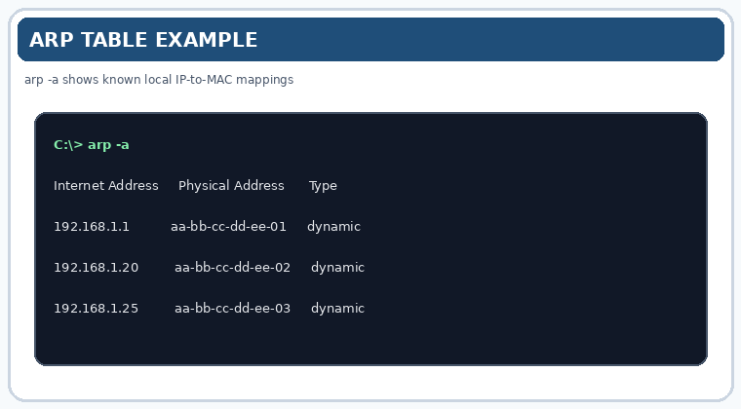
2. Observation Table
Fill in the table using your actual command output.
No. | IP Address | MAC Address | Device / Person
1 | 192.168.1.1 (example) | From arp -a | Wi-Fi router
2 | __________ | __________ | My laptop
3 | __________ | __________ | My mobile phone
4 | __________ | __________ | Family member's phone
5 | __________ | __________ | Smart TV
6 | __________ | __________ | Other device
7 | __________ | __________ | Other device
The addresses above are examples or placeholders; they are not readings from your network.
3. Result
The arp -a command was used to view the local ARP table, which maps known local IPv4 addresses to MAC addresses. The devices can be identified by comparing these results with the connected-device list in the router's admin panel.

Task 5: - Write a one-page report explaining step-by-step how you set up the network, tested connectivity using ping and traceroute, and what results or issues you observed. Include screenshots or command outputs if possible.
Report: Network Setup and Connectivity Testing
1. Objective
To set up a home Wi-Fi network, identify connected devices, and test network connectivity using the ping and tracert commands.
2. Network Setup Procedure
First, I connected my laptop and mobile phone to the same Wi-Fi network. The router was connected to the internet through the ISP connection and modem/ONT. I opened Command Prompt on my Windows laptop and executed the ipconfig command to identify the IPv4 address, subnet mask, and default gateway. I also used arp -a to view known IP-to-MAC address mappings on the local network.
3. Connectivity Testing Using Ping
I used the ping command to test communication between my laptop and another device connected to the same Wi-Fi network.
Command used:
ping [phone IP address]
The command sends ICMP echo requests and displays responses, response times, and packet loss. When the phone was disconnected from Wi-Fi, I repeated the ping test. The expected result was a “Request timed out” message because the phone was no longer reachable through the local network. However, firewall settings or network isolation can also affect the result.
4. Traceroute Testing
I ran the following command to examine the route toward YouTube:
tracert www.youtube.com
The command displayed numbered network hops and the response times for each hop. Some intermediate hops may have shown asterisks or “Request timed out” because certain routers do not respond to traceroute probes. The actual number of hops depends on the network and destination selected at the time of testing.
5. Results and Issues Observed
The ipconfig command helped identify the laptop’s network configuration. The arp -a command displayed known local network address mappings. The ping command was used to test device connectivity, while tracert showed the route toward the destination. Possible issues included request timeouts, blocked ICMP traffic, and devices being unreachable after disconnection.
6. Conclusion
The practical demonstrated how to inspect network settings and use basic Windows networking commands to troubleshoot connectivity. These tools help identify network configuration details, test communication between devices, and investigate the path taken by traffic to an internet destination.

